November 14, 2018  AUTO-CATEGORIZATION SHOWCASE  People, Process & Technology – Learn the steps to success for your organization’s business information! | 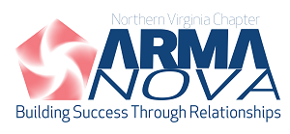
FREE educational event on Wednesday, November 14, 2018, 8:30am - 1pm
Hosted by Grant Thornton LLP in Rosslyn, VA

This FREE educational event is generously brought to you by our experts from–
Concept Searching
Gimmal
Active Navigation & NEOSTEK

This Auto-Categorization Showcase will be more engaging, and more hands-on than most four-hour seminars. Our format is designed to keep presenters and participants "on their toes". This will not be a stuffy presentation in a quiet auditorium. Join us and expand your awareness of advances being made!
Attendees will rotate through three demonstrations or labs hosted by experts at Gimmal, Concept Searching, and Active Navigation & NEOSTEK. All attendees will get a chance to see all three presentations. Each segment will focus on different aspects of auto-categorization:
- Concept Searching will demonstrate how to generate metadata and taxonomy classifications through auto-categorization
- Gimmal will show how to use auto-categorization to power intelligent records management
- Active Navigation and NEOSTEK will lead a “Human vs. Machine” exercise to compare classification of a series of documents manually versus via auto-categorization
By attending this event, you will learn about:
- Capture, classification, and categorization for improvements in productivity, searchability, and findability
- Use of metadata (and advancements in generation of intelligent metadata and the power of taxonomy)
- Updates in integrating tools,
- Applying techniques and approaches to one of the greatest challenges to compliant Information Management
MEETING AGENDA
8:30-9:00 am Registration, breakfast
9:00-9:15 am Welcome and overview
9:25-10:25 am Demo/lab rotation #1
10:35-11:35 am Demo/lab rotation #2
11:45 -12:45 pm Demo/lab rotation #3
12:45-1:00 pm Closing remarks, grab lunch to go

Be sure to reserve your FREE seat
at least one week prior to this event at
www.arma-nova.org

Free registration will close one week prior to the event, and late registrants will be charged $25! Please register early for your FREE seat!
This event is generously hosted by – Grant Thornton, LLP, at 1000 Wilson Boulevard, 19th Floor, Arlington, VA near the Rosslyn Metro Station (Orange, Blue, Silver Lines) – parking available for $12
OUR SPEAKERS
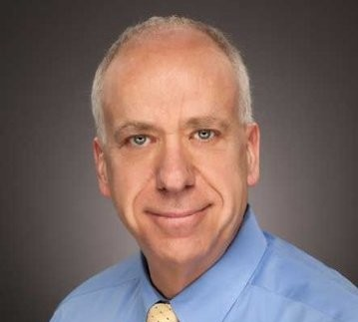
Pat Brim is the Senior Director of Federal for Gimmal with over 30 years of Information Technology experience providing Content and Records Management, Business Process Management and Digital Analytics solutions to the Federal market. He has leveraged his skills in enterprise class implementations within several DoD and Civilian agencies. In his role at Gimmal he coordinated Gimmal’s efforts to become certified against NARA’s Universal ERM requirements and comply with the M-12-18 Directive. Pat is now taking that experience and helping multiple Federal Agencies become compliant by combining Federated and Centralized Records Management approaches to meet their needs.
.

John Cofrancesco, Vice President of Business Development for Active Navigation, has a demonstrated history of working in the DOD, Federal, and computer software industry. He is skilled in Big Data Analytics, Management, Leadership, and Change Management. A graduate of CUA undergrad and the Georgetown University CMAP program, John currently serves as vice president of the ARMA NOVA chapter.

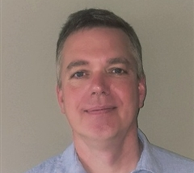
Russ Savee at Gimmal Public Sector has worked in the ECM/eRM industries over the past 20 years as a Technical Project Manager, Consultant and Solutions Engineer, providing expertise delivering enterprise software solutions utilizing leading edge technologies to enhance productivity. Russ has successfully deployed a variety of ECM/ERM software solutions into multiple commercial organizations and Federal agencies.

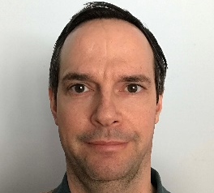
Graham Simms, Director of Delivery and Consulting Services at Concept Searching, has over 20 years’ experience in the IT industry, and received his Bachelor’s degree in Computer Science from the Victoria University of Manchester, where he studied under Professor Steven Furber, developer of the ARM processor. He is an expert in information retrieval and automated document classification solutions, and has developed taxonomies and classification systems for several companies, including AT&T, BP, DAI, and the US Air Force.

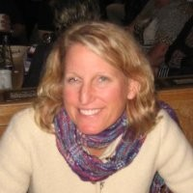
Lisa Vignerot is an Information Architect who has been very successful with implementing Records and Information Management solutions for US Government Agencies including the Department of Homeland Security (DHS), Environmental Protection Agency (EPA), General Printing Office (GPO) and the Office of the President among others. She possesses nearly three decades of experience working in information technology. She is considered a Records and Information Management Subject Matter Expert for Federal Government Agencies. Today, Ms. Vignerot is a Senior Project Manager at NEOSTEK and is responsible for the design and architecture of RIM solutions, including file plans, standard operating procedures, policies and guidelines for use throughout the Federal Agency where she works. She is also responsible for managing unit file plans, working with customers in order to update file plans, and proposes changes for schedules for submission to NARA.

